Beyond Majority Rule: The Case for Pan-African Democracy
By Kirangacha Mwaniki
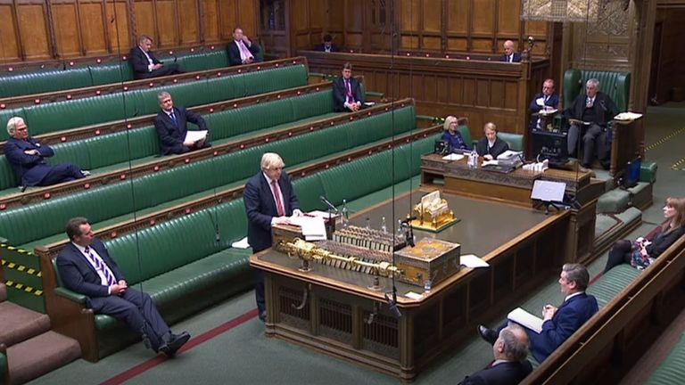
Photo: Sky News 1
Liberal democracy as a system of governance has long been championed by Western powers and their allies, and in many cases strongly imposed on African countries during and after the colonial period, a push that frequently put newly independent administrations at odds with the very populations they governed. This external pressure contributed, in numerous instances, to the birth of new constitutions that shifted greater power to citizens by enshrining individual rights and freedoms. On paper, liberal democracy is a compelling framework. It combines majority rule with protections for minority rights and individual freedoms, resting on a set of core values: majority rule, where citizens vote to choose leaders and the side with the most votes wins; minority rights, where laws protect those who do not belong to the winning group; rule of law, where government and citizen alike are bound by the same legal standards; free and fair elections, allowing leaders to be changed peacefully through regular, open contests; and individual freedoms, including speech, press, and religion.
The difficulty is not with these principles in the abstract. The difficulty is with how they arrived in Africa, and with what was left out along the way.
A System Imposed
Much of liberal democracy's implementation across African regimes came bundled with intimidation, coercion, and considerable imbalance, as departing colonial administrations and their successors worked to ensure that their preferred governance model took root, regardless of whether the societies inheriting it had been given the space to adapt it to their own political realities. Among the five pillars listed above, majority rule took centre stage in this push. Western governments and international institutions have consistently emphasised free and fair elections as the measure of democratic legitimacy, while paying comparatively little attention to the social and political conditions that determine what happens once the votes are counted.
This is where the liberal democratic model, transplanted wholesale onto the African continent, begins to strain. It is widely observed that many African nations remain deeply structured around ethnic identity and communal belonging, and that this reality shapes how people organise themselves politically far more than ideology or policy platforms do. Political parties across much of the continent are frequently built around ethnic or regional coalitions rather than around a coherent, rational, issue-based vision for governance. It is not uncommon to see political leaders mobilise the public along ethnic lines, absent any clear articulation of leadership vision or policy direction, and then present that ethnic coalition at the ballot box as a legitimate majority, entitled to invoke the language of free and fair elections to claim power.
This is the gap that liberal democracy, as exported to Africa, has consistently failed to close. A system built on the premise that the majority's will should govern says very little about how that majority is formed, or whether its formation serves the collective interest of the nation or merely the sectional interest of whichever ethnic bloc manages to out-organise its rivals. African democracies, in many cases, have ended up crowded with corruption, brutality, and intimidation by ruling elites who understood early that liberal democracy's procedural safeguards could be satisfied on paper while its deeper spirit, government by and for the whole people, was hollowed out in practice.
What Majority Rule Was Never Meant to Be
Majority rule must never be reduced to a mechanism by which sectional or even hostile groupings assemble sufficient numbers to seize leadership in pursuit of narrow, individual, or ethnic interest. Democracy, properly understood, must be anchored in ideologies and platforms that advance the interests of an entire nation, not merely the interests of whichever coalition happens to command a plurality on election day. Liberal democracy scores well on several fronts, protection of individual liberties, the rule of law, freedom of expression, but it falls flat precisely where Africa needs it most: in ensuring that the process by which a majority is formed reflects genuine national deliberation rather than ethnic arithmetic.
This is precisely the space Pan-African democracy is positioned to fill.
Pan-African democracy does not reject the values liberal democracy claims to uphold, rule of law, protection of rights, peaceful transfer of power. What it rejects is the assumption that the ballot box, on its own, is a sufficient mechanism for translating those values into legitimate governance in societies still organised significantly along ethnic and communal lines. Long before the colonial encounter, African societies across the continent had developed their own sophisticated systems of collective governance: councils of elders who deliberated until consensus was reached rather than simply tallying votes, communal assemblies where every lineage or clan had a voice in decisions affecting the whole, and mechanisms of accountability rooted in kinship, custom, and communal legitimacy rather than in periodic elections alone. These systems were not perfect, and no serious case for Pan-African democracy should romanticise them uncritically. But they shared a common insight that liberal democracy's majoritarian model too often ignores: that legitimate governance requires the active inclusion and buy-in of all significant constituent groups, not merely the temporary alliance of whichever coalition can muster fifty percent plus one.
A Pan-African democratic model, then, would draw on this indigenous inheritance while retaining what liberal democracy genuinely gets right. It would combine free and fair elections with deliberate, constitutionally embedded mechanisms for power-sharing and consensus-building across ethnic and regional lines, ensuring that no single group can capture the state entirely on the strength of numbers alone. It would insist that political parties organise around ideology and policy platforms rather than ethnic mobilisation, using legal and institutional levers, campaign finance rules, party registration requirements, civic education, to actively discourage the ethnic coalition-building that has hollowed out liberal democracy's promise across the continent. And it would treat minority protection not merely as a constitutional afterthought bolted onto a majoritarian system, but as a structural feature of how power itself is organised and exercised.
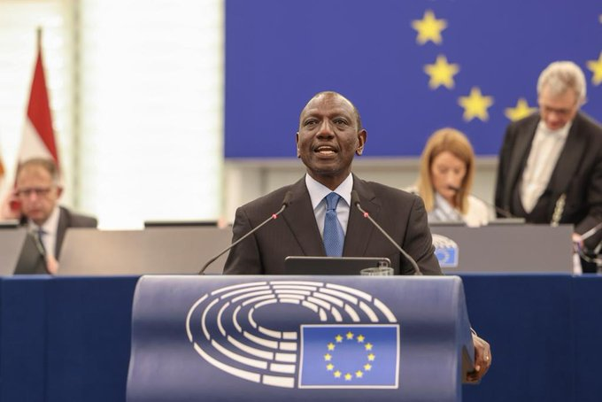
President William Ruto addresses the European Parliament in Strasbourg
It is worth acknowledging, honestly, that consensus and power-sharing models have not always delivered on their promise elsewhere on the continent. Critics point to Uganda's Movement System of the 1980s and 1990s, which was framed as a homegrown alternative to divisive multi-party competition but was widely seen, over time, to have entrenched a single leadership well beyond what genuine consensus-building would justify. Rwanda's post-1994 governance arrangements are cited in similarly divided terms, credited by some for rebuilding national unity after genocide through deliberate power-sharing and reconciliation structures, while criticised by others as a framework that has, in practice, narrowed political space and shielded incumbency from serious challenge. These examples are a legitimate caution, not a rebuttal. They demonstrate that any model built around consensus and inclusion, Pan-African or otherwise, can be captured by the same elites it was designed to restrain, if it is not paired with genuine institutional accountability, term limits, and independent oversight. The answer is not to abandon the search for a governance model suited to Africa's social realities, but to build one with these historical cautionary tales in view, rather than repeating them.
Which Way Africa Chooses
None of this amounts to a rejection of democracy itself, nor a case for authoritarianism dressed in African garb, a trap some regimes have historically used to justify entrenchment and abuse. It is, instead, a case for democratic maturity: a recognition that the specific procedural form liberal democracy took in the West, one shaped by centuries of its own political development, including the gradual, often painful management of its internal divisions, cannot simply be transplanted onto societies with a fundamentally different social architecture and be expected to function identically. Africa does not need to import a finished product. It needs the space and the confidence to build governance systems that take seriously both the values liberal democracy espouses and the social realities liberal democracy, as practised on the continent, has too often failed to reckon with.
The case for Pan-African democracy, then, is not a case against the ballot box. It is a case for what must surround the ballot box if it is to produce governments that serve the whole nation rather than merely the winning coalition. That is the unfinished work liberal democracy left behind in Africa, and it is the work Pan-African democracy must now take up.
Kirangacha Mwaniki is CEO of Virtue Book Publishers and Executive Director of Virtue Literacy Africa. He writes on publishing, literacy, and African governance.

